- Save Player

Post Request
http://localhost:5003/LeaderBoard/player/Saveplayer/

Input

{
"playerName": "Rajanikansdsdtdssds21",
"playerAge": "54546",
"emailId": "ryadav@ssdds.cossm",
"totalScore": "1"
}

Output
{
"playerId": 66,
"playerName": "Rajanikansdsdtdssds21",
"playerAge": "54546",
"emailId": "ryadav@ssdds.cossm",
"totalScore": 1
}

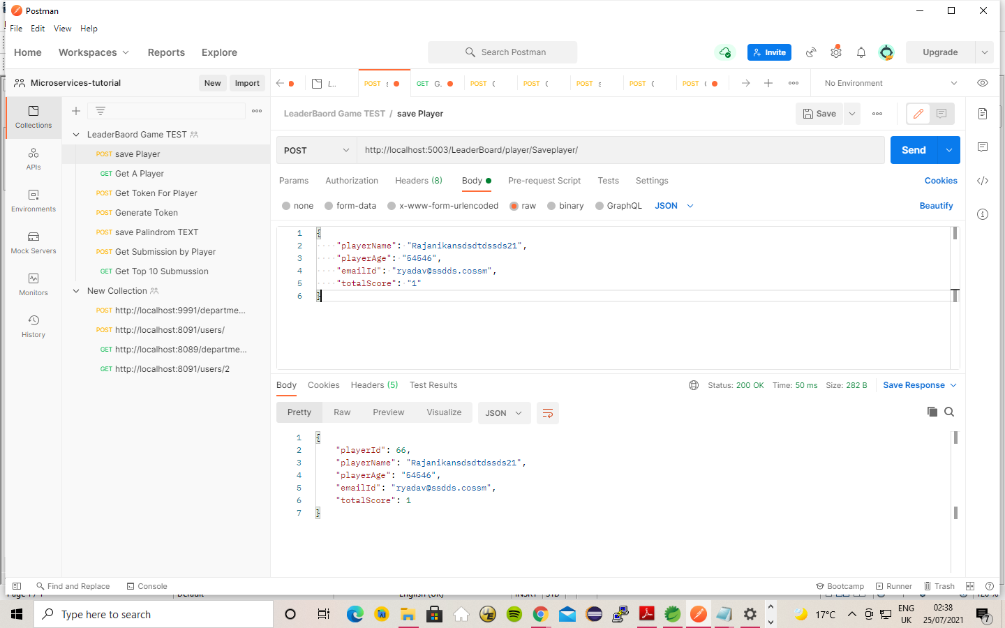

2) get Player

Get Request

http://localhost:5003/LeaderBoard/player/getplayerById/66

Output

{
"playerId": 66,
"playerName": "Rajanikansdsdtdssds21",
"playerAge": "54546",
"emailId": "ryadav@ssdds.cossm",
"totalScore": 1
}

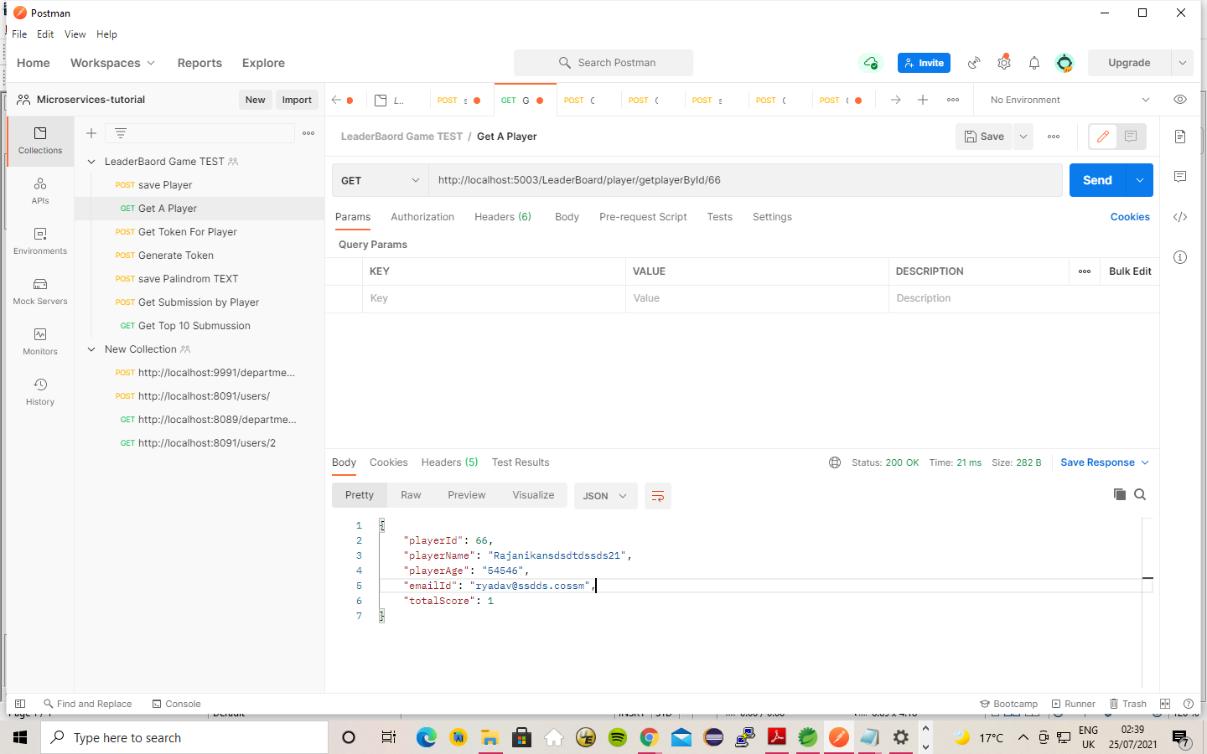

3) Generate Token

Post Request
http://localhost:5003/LeaderBoard/token/GenerateToken/

Input

{
"playerId": 33,
"playerName": "Rajanikansdsdtdssds21",
"playerAge": "54546",
"emailId": "ryadav@ss.cosm",
"totalScore": 1
}

Output
{
"tokenId": 2,
"accessToken": "20210724213116",
"playerID": 33,
"generateTimeStamp": "2021.07.24 21:31:16"
}

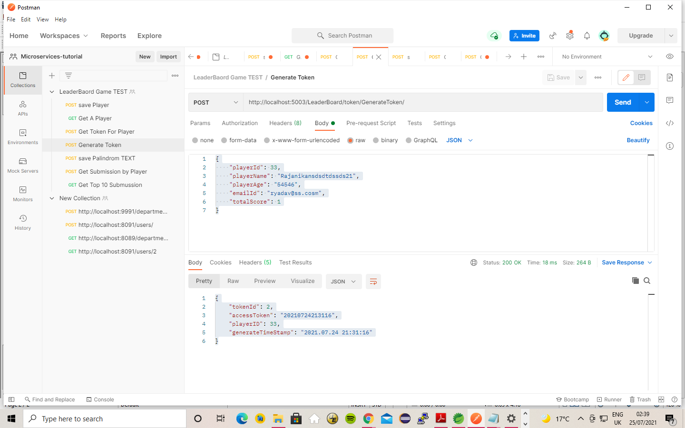

4) Get Token for a player :

Post request

http://localhost:5003/LeaderBoard/token/getToken/

Input

{
"playerId": 66,
"playerName": "Rajanikansdsdtdssds21",
"playerAge": "54546",
"emailId": "ryadav@ssdds.cossm",
"totalScore": 1
}

Output

{
"tokenId": 1,
"accessToken": "20210724212914",
"playerID": 66,
"generateTimeStamp": "2021.07.24 21:29:14"
}

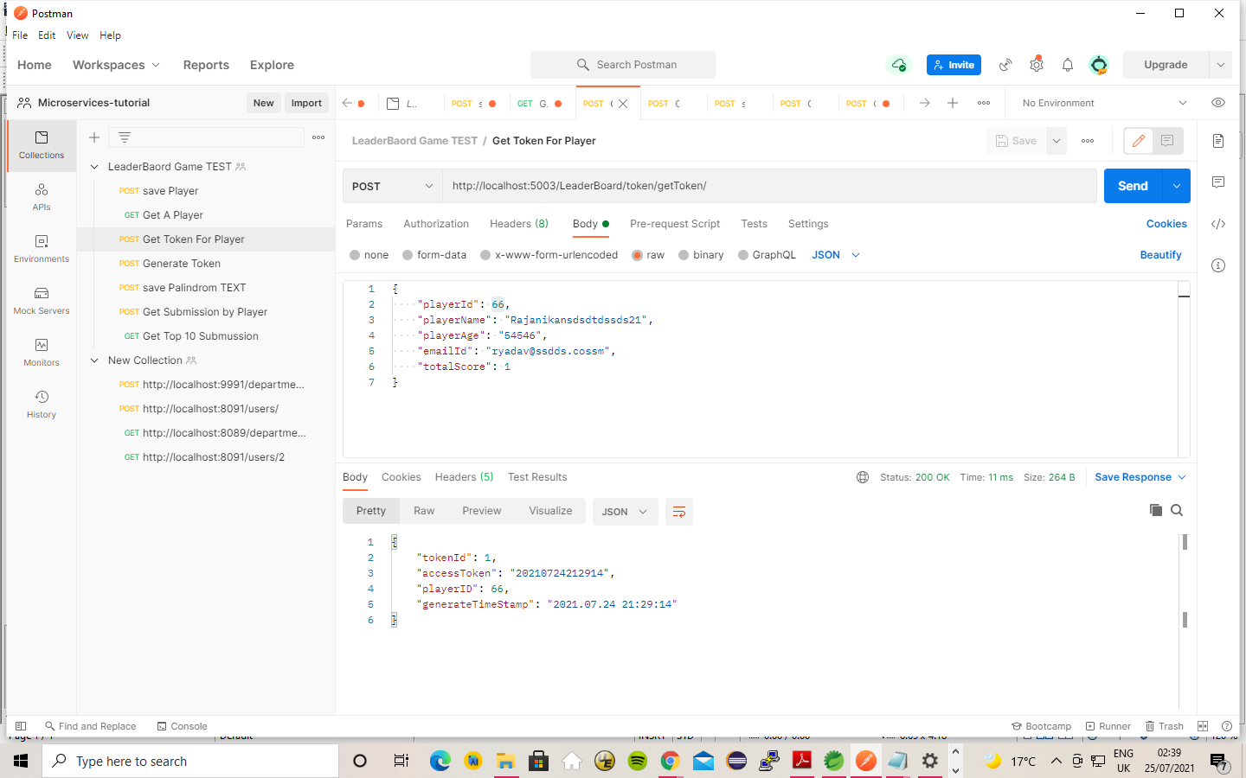

5) Submit Text

http://localhost:5003/LeaderBoard/submission/SaveSubmission/

input

{
"playerID": 66,
"tokenId": 2,
"accessToken": "20210724212914",
"text": "TET Sir, I demand, I am a maid named Iris TET"
}

Output
{
"submissionId": 38,
"playerID": 66,
"tokenId": 2,
"accessToken": "20210724212914",
"text": "TET Sir, I demand, I am a maid named Iris TET",
"score": 45,
"status": "Success",
"message": "Submissonwas successfull"
}

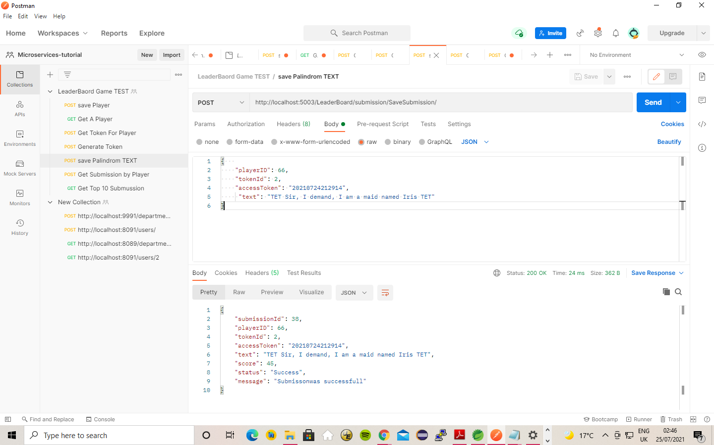

6) Get Submission by Player

http://localhost:5003/LeaderBoard/submission/getSubmissionByPlayer/

Input :

{
"tokenId": 2,
"accessToken": "20210724213116",
"playerID": 33,
"generateTimeStamp": "2021.07.24 21:31:16"
}

Output :

[
{
"player": {
"playerId": 33,
"playerName": "Rajanikansdsdtdsds21",
"playerAge": "54546",
"emailId": "ryadav@ss.cosm",
"totalScore": 1
},
"submission": {
"submissionId": 33,
"playerID": 33,
"tokenId": 2,
"accessToken": "20210724213116",
"text": "Sir, I demand, I am a maid named Iris",
"score": 37,
"status": "Success",
"message": "Submissonwas successfull"
}
},
{
"player": {
"playerId": 33,
"playerName": "Rajanikansdsdtdsds21",
"playerAge": "54546",
"emailId": "ryadav@ss.cosm",
"totalScore": 1
},
"submission": {
"submissionId": 34,
"playerID": 33,
"tokenId": 2,
"accessToken": "20210724213116",
"text": "TET Sir, I demand, I am a maid named Iris TET",
"score": 45,
"status": "Success",
"message": "Submissonwas successfull"
}
},
{
"player": {
"playerId": 33,
"playerName": "Rajanikansdsdtdsds21",
"playerAge": "54546",
"emailId": "ryadav@ss.cosm",
"totalScore": 1
},
"submission": {
"submissionId": 35,
"playerID": 33,
"tokenId": 2,
"accessToken": "20210724213116",
"text": "TET Sir, I demand, I am a maid named Iris TET",
"score": 45,
"status": "Success",
"message": "Submissonwas successfull"
}
},
{
"player": {
"playerId": 33,
"playerName": "Rajanikansdsdtdsds21",
"playerAge": "54546",
"emailId": "ryadav@ss.cosm",
"totalScore": 1
},
"submission": {
"submissionId": 36,
"playerID": 33,
"tokenId": 2,
"accessToken": "20210724213116",
"text": "TET Sir, I demand, I am a maid named Iris TET",
"score": 45,
"status": "Success",
"message": "Submissonwas successfull"
}
}
]

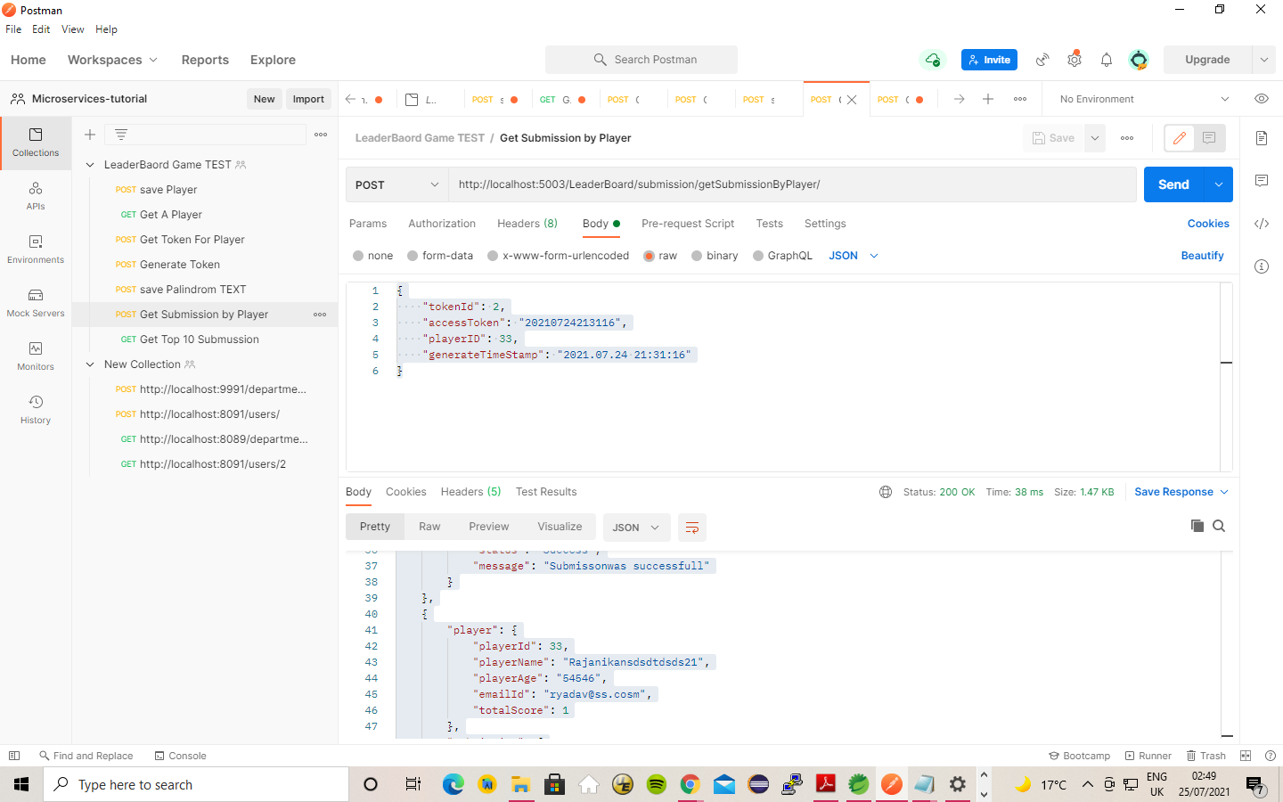

7) Get Top 10 Submussion

Post request

http://localhost:5003/LeaderBoard/submission/getTopsubmission/

{
"tokenId": 2,
"accessToken": "20210724213116",
"playerID": 33,
"generateTimeStamp": "2021.07.24 21:31:16"
}

[
{
"player": {
"playerId": 33,
"playerName": "Rajanikansdsdtdsds21",
"playerAge": "54546",
"emailId": "ryadav@ss.cosm",
"totalScore": 1
},
"submission": {
"submissionId": 33,
"playerID": 33,
"tokenId": 2,
"accessToken": "20210724213116",
"text": "Sir, I demand, I am a maid named Iris",
"score": 37,
"status": "Success",
"message": "Submissonwas successfull"
}
},
{
"player": {
"playerId": 33,
"playerName": "Rajanikansdsdtdsds21",
"playerAge": "54546",
"emailId": "ryadav@ss.cosm",
"totalScore": 1
},
"submission": {
"submissionId": 34,
"playerID": 33,
"tokenId": 2,
"accessToken": "20210724213116",
"text": "TET Sir, I demand, I am a maid named Iris TET",
"score": 45,
"status": "Success",
"message": "Submissonwas successfull"
}
},
{
"player": {
"playerId": 33,
"playerName": "Rajanikansdsdtdsds21",
"playerAge": "54546",
"emailId": "ryadav@ss.cosm",
"totalScore": 1
},
"submission": {
"submissionId": 35,
"playerID": 33,
"tokenId": 2,
"accessToken": "20210724213116",
"text": "TET Sir, I demand, I am a maid named Iris TET",
"score": 45,
"status": "Success",
"message": "Submissonwas successfull"
}
},
{
"player": {
"playerId": 33,
"playerName": "Rajanikansdsdtdsds21",
"playerAge": "54546",
"emailId": "ryadav@ss.cosm",
"totalScore": 1
},
"submission": {
"submissionId": 36,
"playerID": 33,
"tokenId": 2,
"accessToken": "20210724213116",
"text": "TET Sir, I demand, I am a maid named Iris TET",
"score": 45,
"status": "Success",
"message": "Submissonwas successfull"
}
},
{
"player": {
"playerId": 66,
"playerName": "Rajanikansdsdtdssds21",
"playerAge": "54546",
"emailId": "ryadav@ssdds.cossm",
"totalScore": 1
},
"submission": {
"submissionId": 37,
"playerID": 66,
"tokenId": 2,
"accessToken": "20210724213116",
"text": "TET Sir, I demand, I am a maid named Iris TET",
"score": 45,
"status": "Success",
"message": "Submissonwas successfull"
}
},
{
"player": {
"playerId": 66,
"playerName": "Rajanikansdsdtdssds21",
"playerAge": "54546",
"emailId": "ryadav@ssdds.cossm",
"totalScore": 1
},
"submission": {
"submissionId": 38,
"playerID": 66,
"tokenId": 2,
"accessToken": "20210724212914",
"text": "TET Sir, I demand, I am a maid named Iris TET",
"score": 45,
"status": "Success",
"message": "Submissonwas successfull"
}
}
]

